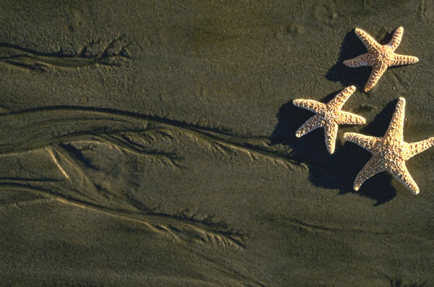

2004 CPC Summer Program Listing

Wishing everyone a wonderful summer.

Weekly –
Terrific Tuesdays
Tuesdays at 10:00 am for parents & children – we invite you to the fun outings.
Please see the foyer table for upcoming events listed.

Summer Bible Study (Graduate/Professional and New Haven Small Group combined)
Meet on Thursday evenings 7:00 – first study will be on June 3rd here at CPC.
Note – please see additional dates listed in the upcoming bulletin announcements.

Monthly events -
June
Friday, June 4th—Movie Night at CPC—8:30 pm – movie playing is “Shrek”
Friday, June 11th – Small Group Prayer and Praise fellowship – please join us at 7 pm here at CPC – watch for future dates in upcoming bulletin announcements throughout the summer.
Sunday, June 13th—Fellowship Meal after Sunday School
Saturday, June 19th—CPC Workday
Sunday, June 20th—Father’s Day
Monday, June 21st – REGISTRATION due for Youth Theology Camp
Friday, June 25th—July 3rd—Missions Trip to Guatemala

July
Friday, July 9th & 23rd —Movie Night at CPC—8:30 pm
Sunday, July 18th—Fellowship Meal after Sunday School – Mission Team to report during Sunday School about their trip to Guatemala
Wednesday, July 21st – Lake Day at the Hawkes – 10:00 am (Rain Date is scheduled for July 22nd same time)
Saturday, July 24th— CPC Beach Day
Monday July 26th—30th—Youth Theology Camp— Year 1 (Boston)

August
Saturday, August 14th—Canoe Trip
Friday, August 20th—Movie Night at CPC — 8:30 pm
Sunday, August 29th—Last Gasp Picnic—Foote Park in Branford

⇦ Be sure to check the website at www.christpresnewhaven.org for current information, small group listing and announcements. ⇨

